**Nand gate design using cadence**

**Submitted by,**

**Manoj M (20bec037)**

**Jai Prasanth C (21bec330)**

**Tegeshwaran G P (20bec061)**

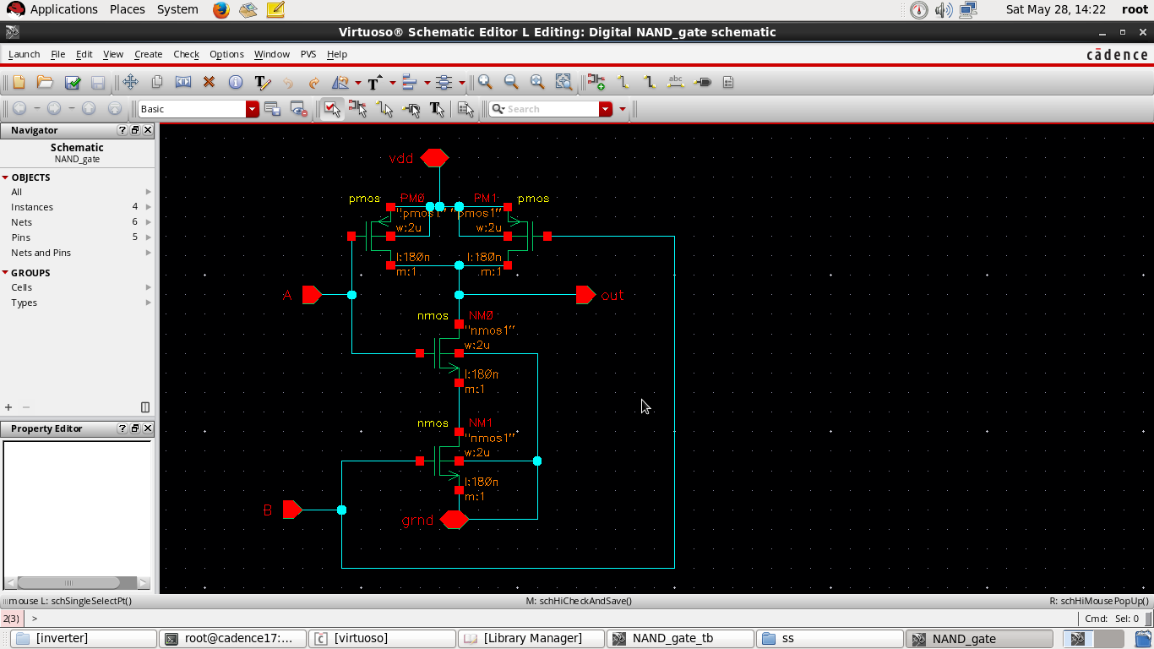**Schematic:**

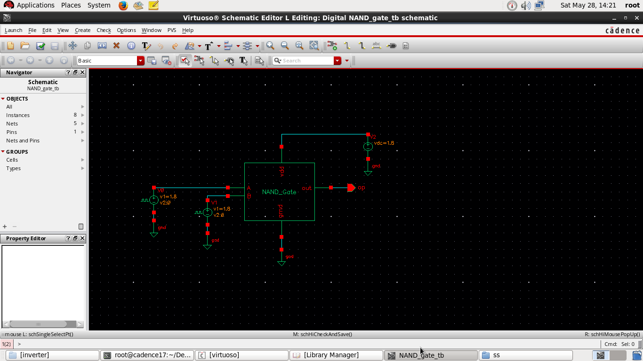Symbol:

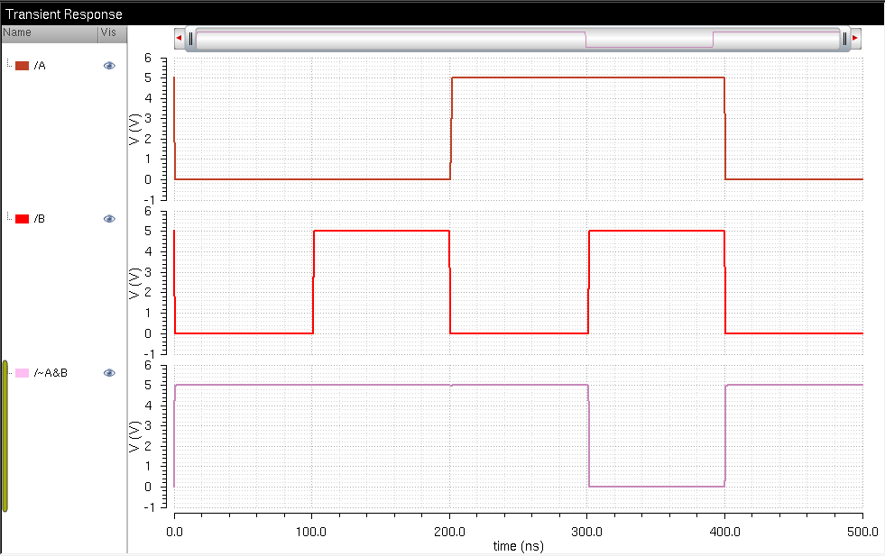Simulation:

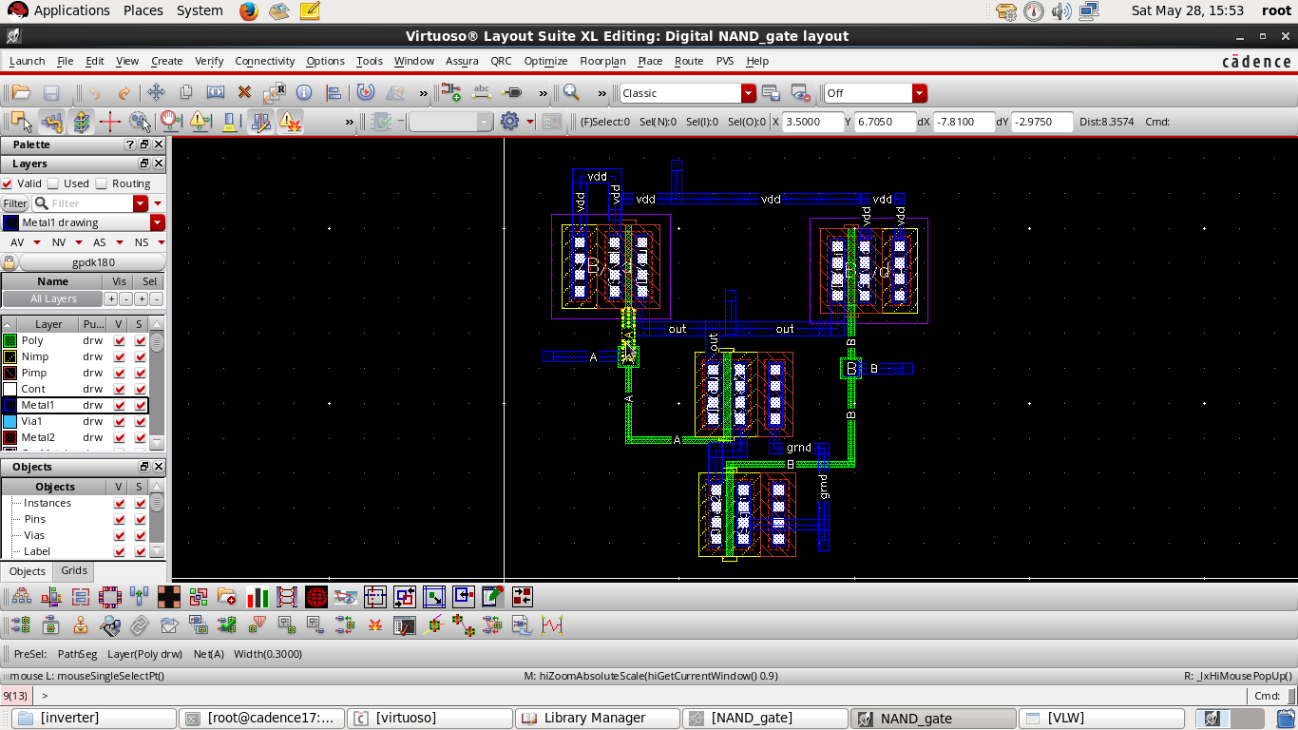Layout:

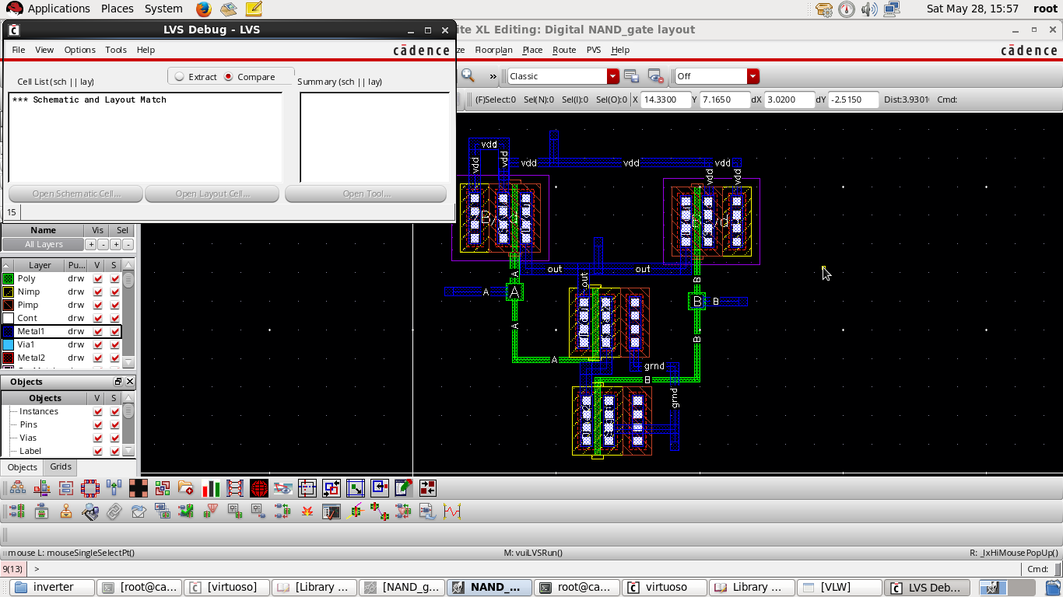Layout vs Schematic(LVS):

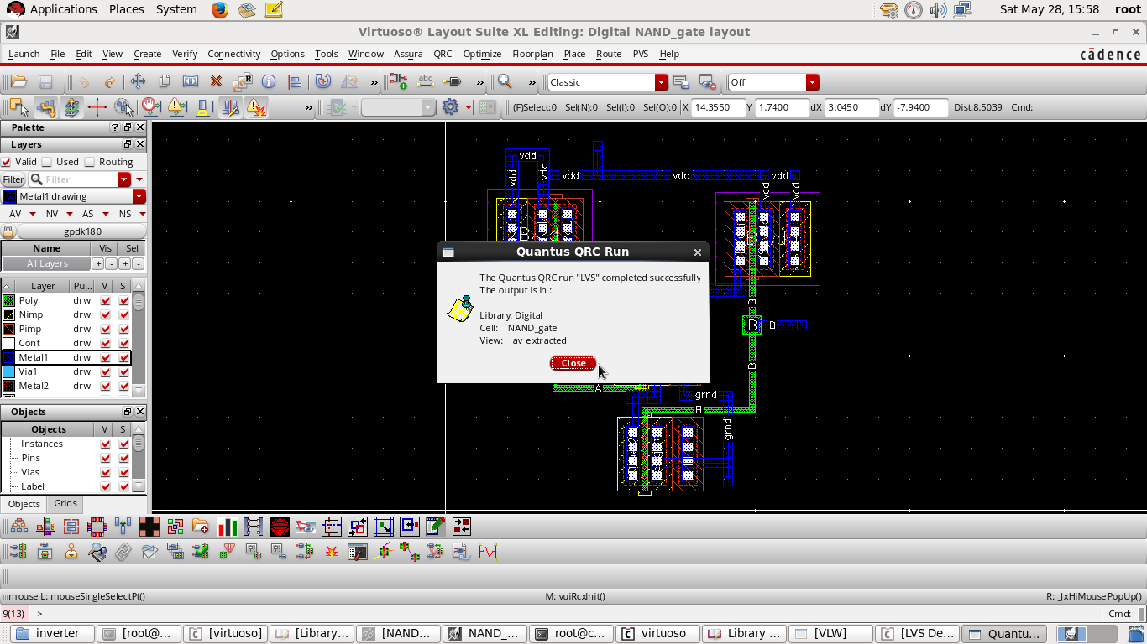QRC:

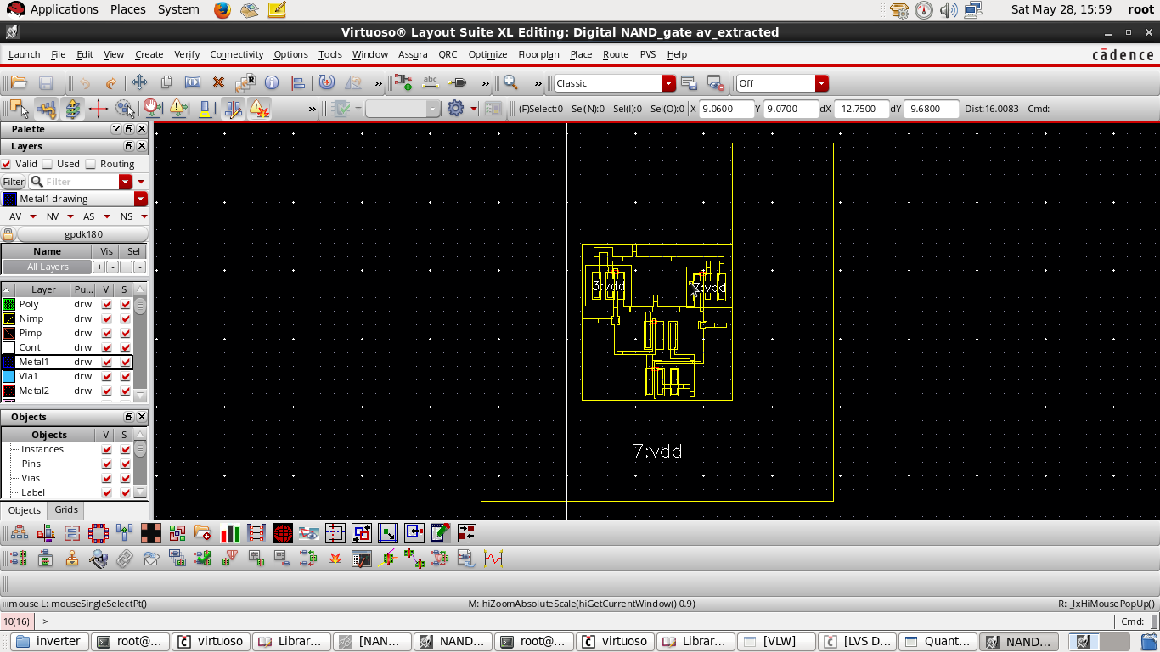Resistance capacitance extraction result: